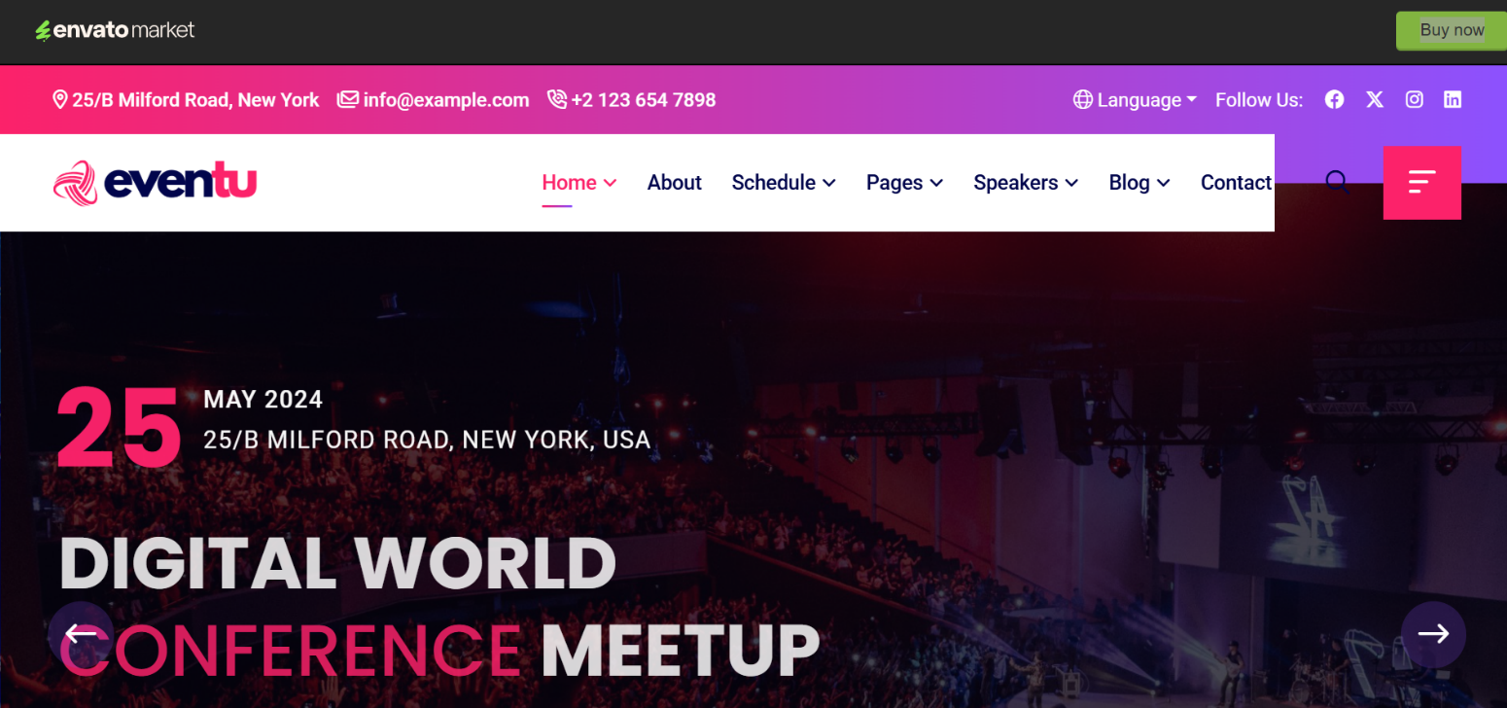
Home | About | Sponsors | Speakers |Previous Editions | Gallery |Book Your Stand | Contact | Agenda
Realtek Summit 2026 Logo
Realtek Conference and Expo
September 24 2026
Dubai UAE

Register as Visitor/
Delegate

Register as Media
Apply to Speak
Nominate for Awards
Book an Exhibition Space

Become a Sponsor

Venue: Dubai, UAE
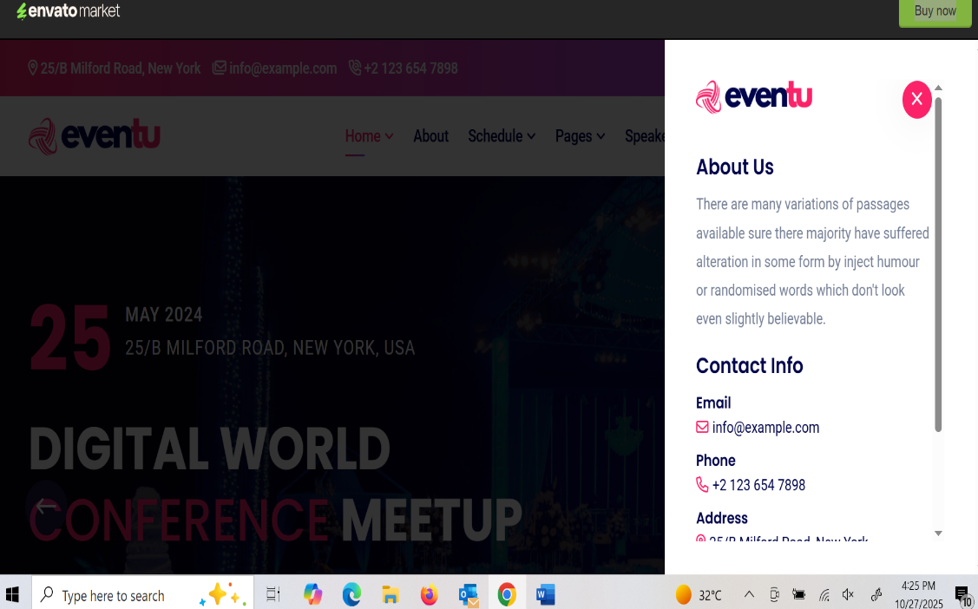
Leading the Future of Real Estate
24th September, 2026 | Dubai
Be part of the region’s premier Realtek summit 2026.
From global leaders to regional pioneers’ network, exhibit, and celebrate excellence.

🔗 Connect with Us
📍 Venue: Dubai, India
📞 Phone: +971 54 232 0399
+971502989588
✉️ Email: eventmanager@ariesgroupglobal.com
🌐 Website: www.Realtek.com
🔹 Follow Us:
| LinkedIn |

Step into the future
of Real Estate Expo and Summit


Organized by Biz Events, Realtek Summit 2026 returns to Dubai, UAE!
Join global innovators, technology pioneers, and industry leaders as they converge to explore the transformative trends shaping connectivity, semiconductors, and smart solutions. Discover the next frontier of Realtek innovation—all from the vibrant heart of the Middle East.
Exihibition Tab
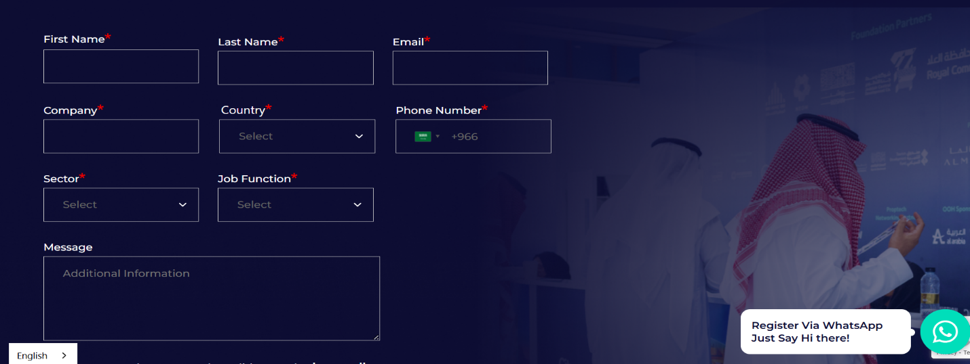

For Exhibition registration details
Add Some Photos Of Kiosks Or Stalls From Events

